**CAPSTONE PROPOSAL**

**Background:**

I came up this idea when thinking of purchasing magic cards through a local Facebook group. I thought how tedious it was that there were multiple groups to browse through and find what I was looking for. Each group fallowed its own price source (TCG player, Star City Games, Face to Face games, etc.) and used those prices for trading cards and play mats. I felt that this could be at least put into one place like Kijiji or Craigslist, but targeted in a way to make searching for what you want easier. Some ideas I had were searching for condition, brand, manufacturer, and pricing.

**Description:**

For my project I plan on developing for the LAMP stack. I plan to build my web application with PHP, HTML 5, CSS, JavaScript, JQuery, and MySQL. I intend to use the CodeIgniter framework to aid me in developing this app along with Twitter Bootstrap for the front end styling and layout. For this project I will use Selenium IDE for testing, phpMyAdmin for MySQL database work, Notepad++ for writing PHP code, and BitBucket and Git for project storage and versioning.

This application will feature two levels of access. The User level which has the ability to view ads, publish ads, report ads, message and reply to users. The final level of access is the Admin access, the admin will have all the abilities of a user along with the ability to add new categories, manufacturers, and brands to expand the search options. They will also have the ability to see what ads or messages have been reported and ban users that have made inappropriate ads or sent offensive messages.

**Functionality chart:**

|  |  |  |
| --- | --- | --- |
|  | User | Admin |
| View ads | x | x |
| Post ads (public/private) | x | x |
| Delete ads | x | x |
| Search for ads with multiple search options (category, type, condition, etc.) | x | x |
| Send and receive messages | x | x |
| Flag messages for offensive content | x | x |
| Flag ads for offensive content | x | x |
| Create accounts | x | x |
| Delete user accounts |  | x |
| Review flagged messages |  | x |
| Review flagged ads |  | x |
| Add new search categories (i.e. brand, category) |  | x |
| Ban users |  | x |

**Home page**:

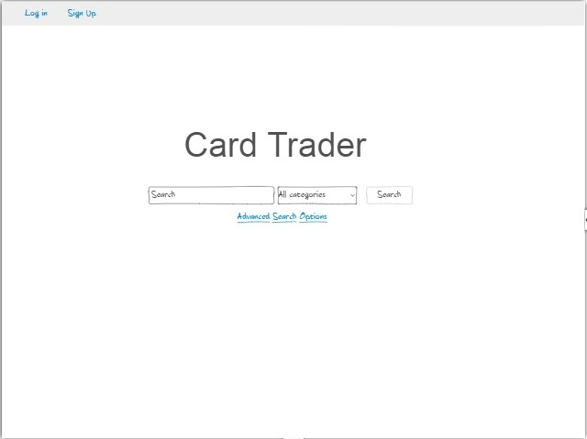**Figure 1 – index page**

This is the index page displayed when a user loads the site, and is not logged in. They are given the option of searching and seeing ads, creating an account or logging in. The user can return by clicking the home button on subsequent pages when they wish to return to this page. If the user clicks on Advanced Search Options, a form is displayed with additional search options to optimize their search results.

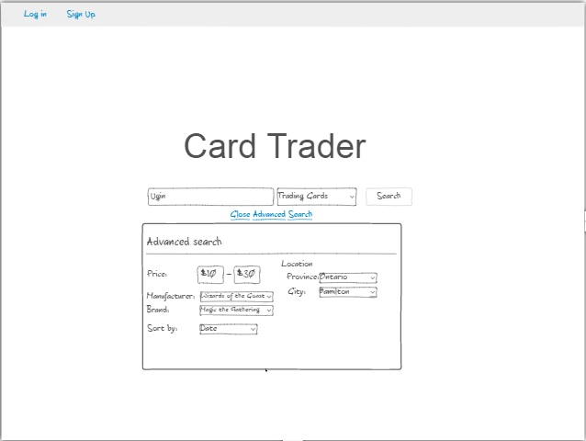  
**Figure 2 – Robust Search**

Upon clicking Open Advanced Search users are greeted with this form containing options such as location, price range, manufacturer, brand, and a sort. This works in conjunction with the search bar and category drop down menu.

**Search page:**

**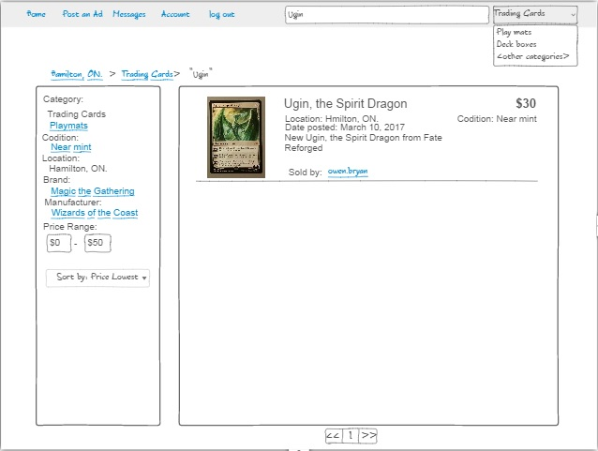  
Figure 3 – Search page**

This is the search page. It will display the results of what you typed in the search bar and displays results found in the category you selected. This page, in the center, will display a table of ad listings based around your search. On the left is an area featuring more search options such as Category, item condition, location, what game it is from, a sort for price and posting, and who made said item. There is also a price range option if the user wants the item in a specified price range.

The listings will be displayed with their title, location, date posted, a short description, the seller’s name, condition and price.

A noticeable change from the home page is the top bar features a search textbox and a category drop down menu. If the user is logged in a messages, account, and log out option will be displayed to the user.

**Post Page:**

**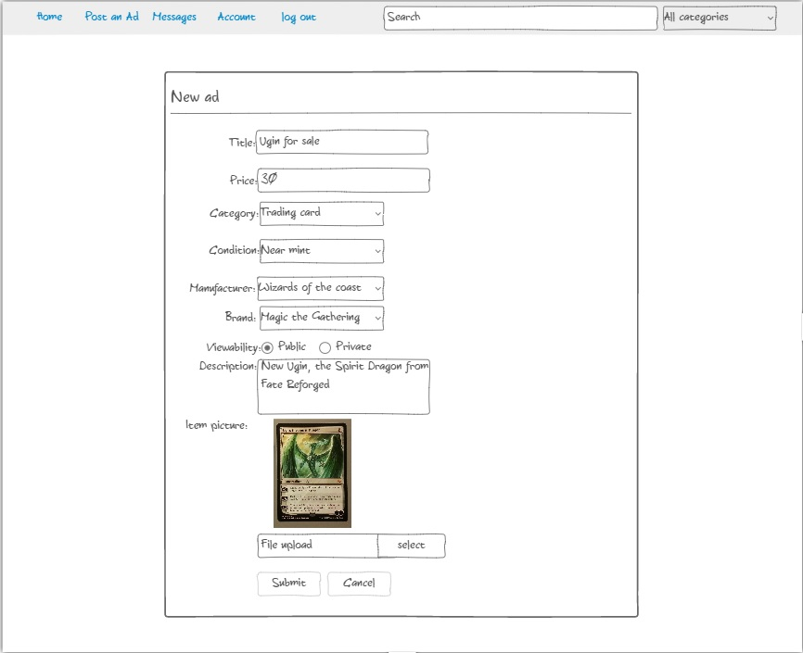  
Figure 4 – Post page**

This is the post page, the user inputs the details (title, price, category, item condition, visibility to others, description, and the picture) about the item they are selling and can choose ether to post it publicly or not. If the ad is set to private, the user would have to supply the URL to the interested party for them to see it. When posted publicly the user can receive messages about their posting including offers.

**Ad Page:**

**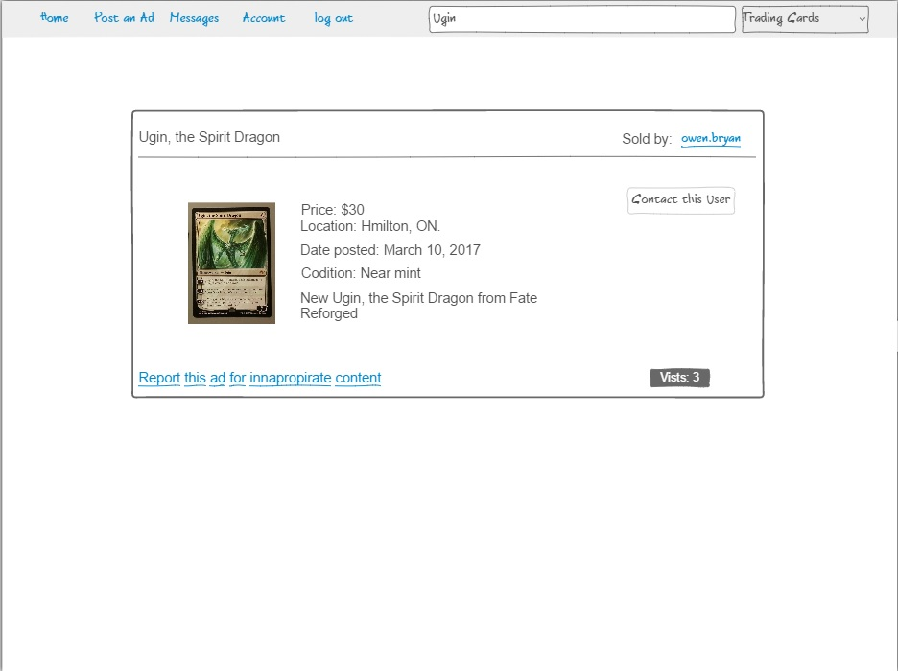  
Figure 5 – Ad Page**

This is the ad page, after the user clicks on an ad they are redirected to this page. It displays the Ad title in the top left, the seller in the top right, the details and image in the center of the body, a link to flag this ad for offensive content, and a button to contact the seller. It also features a view counter that displays how many times this ad was visited.

**User’s Ad page**

**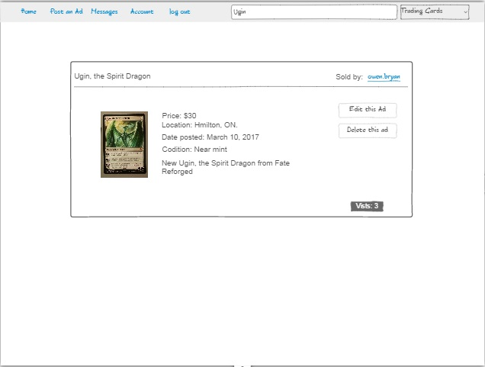  
Figure 6 – User’s Ad page**

This is the ad page from the user’s perspective. Instead of the contact this user button they are given an edit this ad button. When clicked it will take them to the posting page where they can change the details about their ad (i.e. title, description, price, picture, visibility, etc.).

**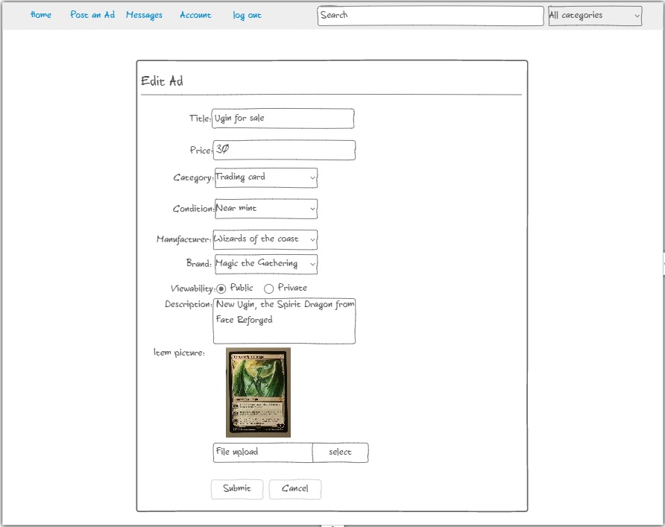  
Figure 7 – Edit Ad**

This is the page the user is brought to when they click edit ad on their own ad postings. They can change every detail about the ad to what they want.

**Login Page:**

**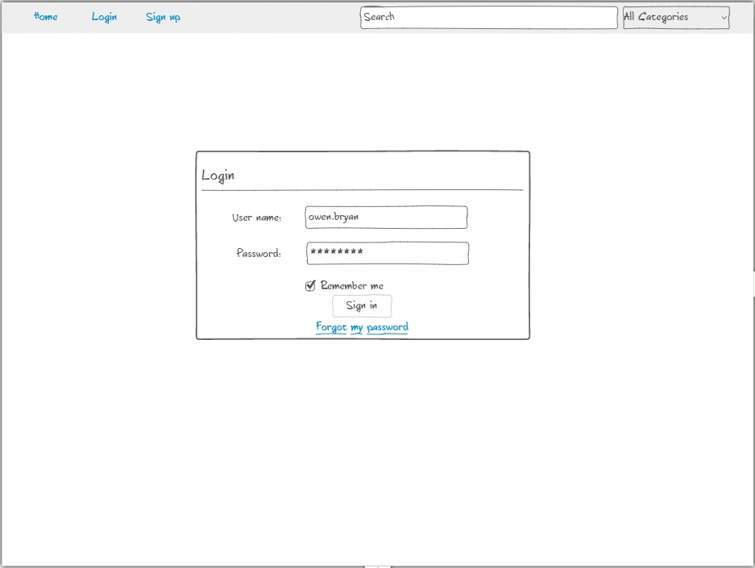  
Figure 48 – Login page**

This is the login page. The page contains a form consisting of two fields and a checkbox for remembering the user next time they want to log in. When the user logs in the navigation bar will change to show their current state and role.

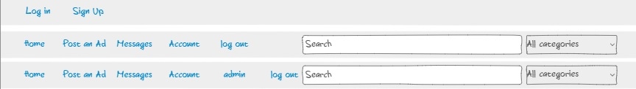  
**Figure 59 – The different navigation bar states**

Depending on if the user is not logged in, logged, or an admin the navigation bar will display accordingly. If the user is an admin they will have an additional button to take them to the admin panel to use functions such as adding or deleting categories, adding new brands and manufacturers, reviewing reported messages and reported ads, and deleting offensive ands or banning users for breaking the rules.

**Password Recovery:**

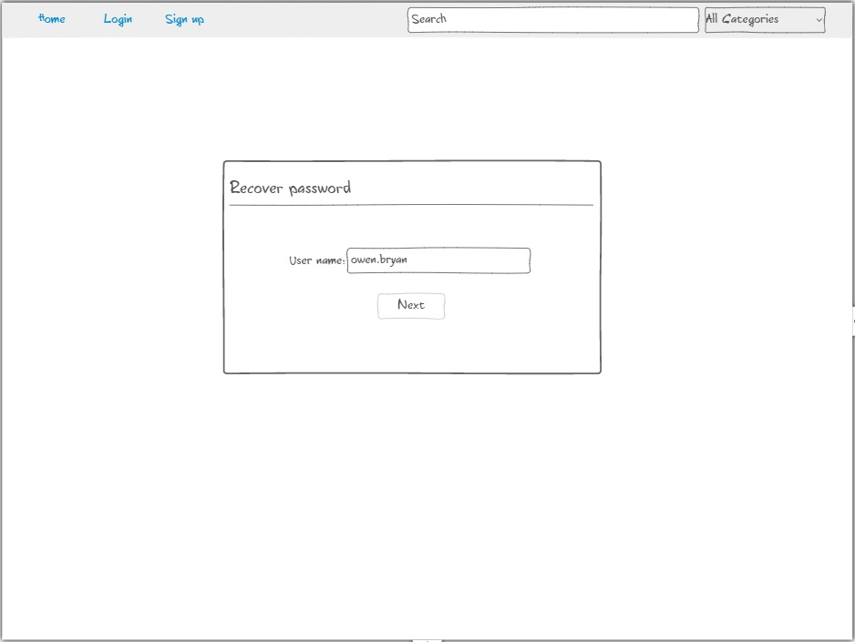  
**Figure 610 - The first password recovery prompt**

In the login page, when you click forgot my password, it will bring you to this page. Here you can enter your user name to begin the first step to resetting your password.

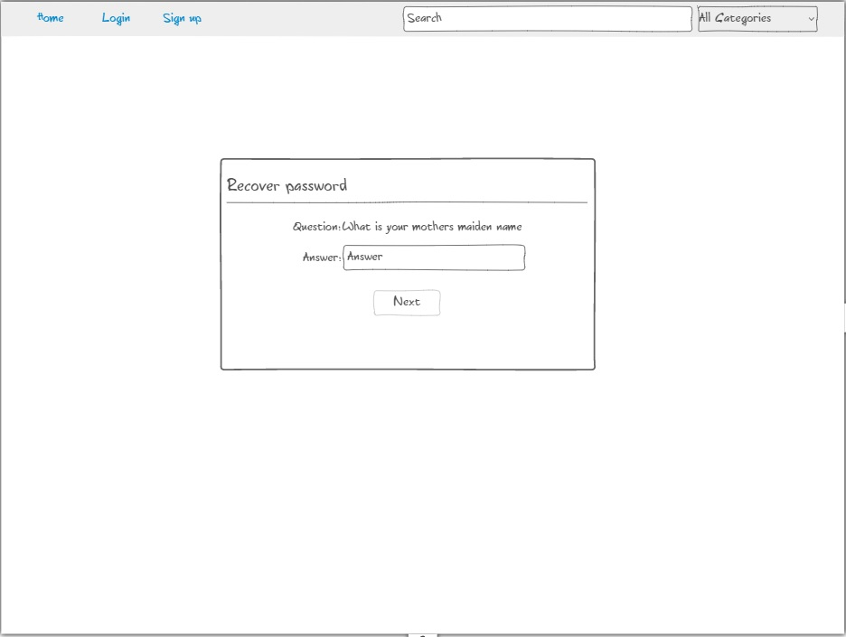  
**Figure 711 – The second password recovery page**

Once you enter your user name, you are presented with this screen. It will ask you for the answer to your security question. If you answer wrong you will be given an error telling you that you are incorrect. If you are correct it will take you to a screen to reset your password.

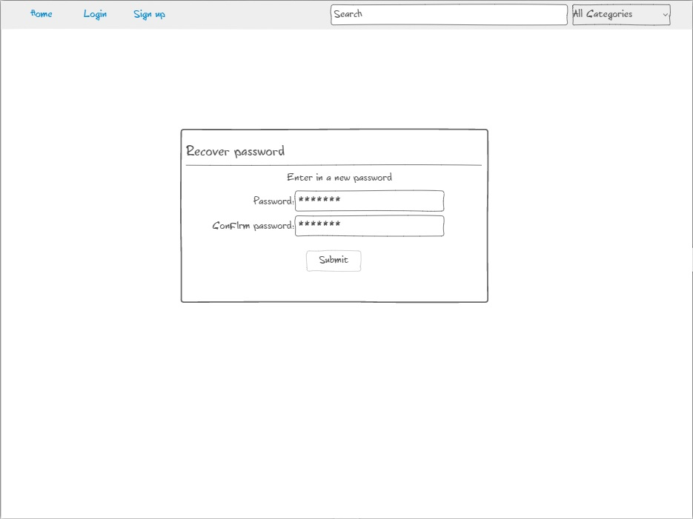  
**Figure 812 – The final password recovery page**

If you enter the correct answer to your question you will be brought to this page to reset the password on your account. On success it will redirect you to the login page with a notification that the password was reset.

**User Signup Page:**

**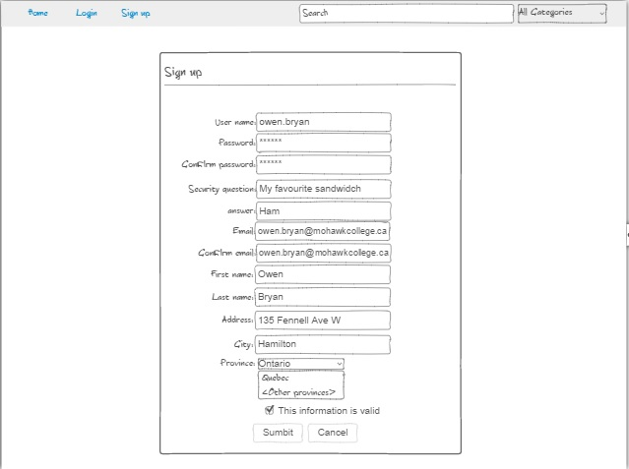  
Figure 911 – The user sign up page**

This is the page the user is taken to when they click the sign up link displayed on the first page and on the navigation bar. Here the user inputs their desired user name and password into the form along with all their information such as email, name, and address.

**Messages:**

**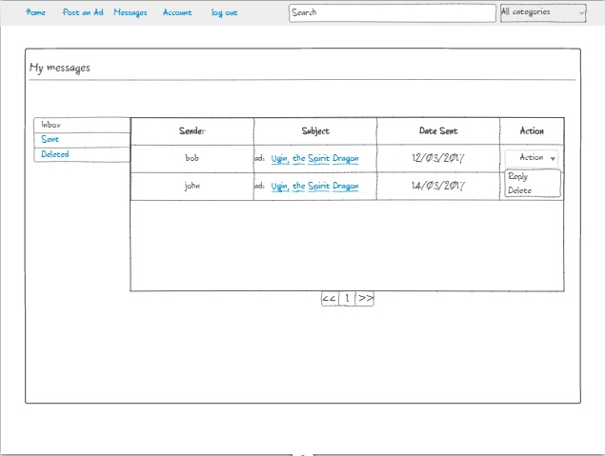  
Figure 12 – Messages Page**

When the user clicks on messages they are brought to this page. In the middle the user can see the messages they have received with details such as sender, subject, and date sent. Next to each message is a drop down menu containing options. The user can either reply to or send to the deleted messages folder. If the user clicks on the subject they are brought to the ad the message is concerning. If the user clicks on the message its self they are brought to a new page containing just the message.

**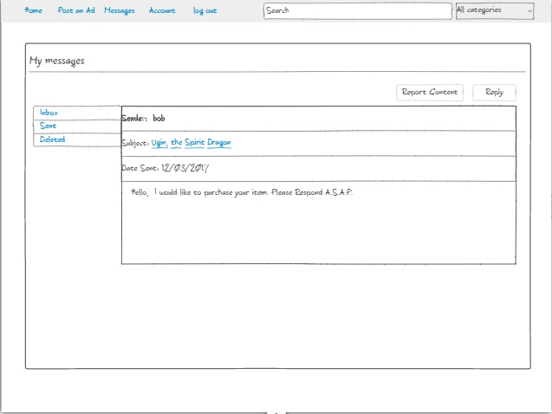  
Figure 13 – User Message**

When the user clicks on a message they are brought to this page. Here they will see the sender name, the subject, date sent, and the content of the message. Like on the previous screen if they click on the subject they will be brought to the ad that the message concerns. In the top right they have two buttons. The one on the left will report the message for inappropriate content such as offensive language, the one on the right will let the user reply to the sender’s message.

**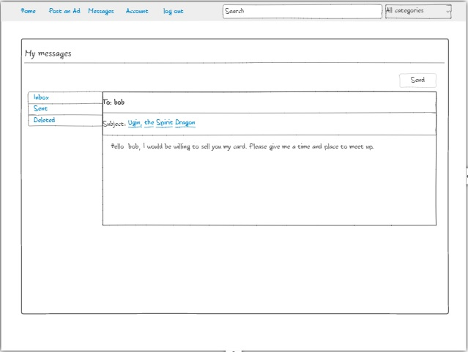  
Figure 14 – User Reply**

This is the user reply screen. When they press the reply button all they have to do is type in their reply and press the send button so the other user can get their message.

**Admin Panel:**

**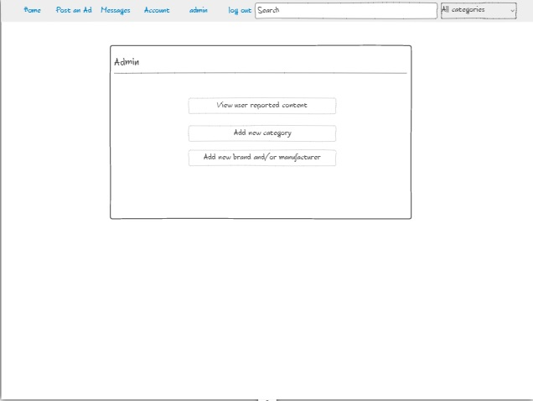  
Figure 15 – Admin panel**

This is the admin panel. Here the admin is granted three options. The option to view content reported by users, add a new category, or add a new brand and/or manufacturer. When an option is clicked they are brought to a corresponding page.

**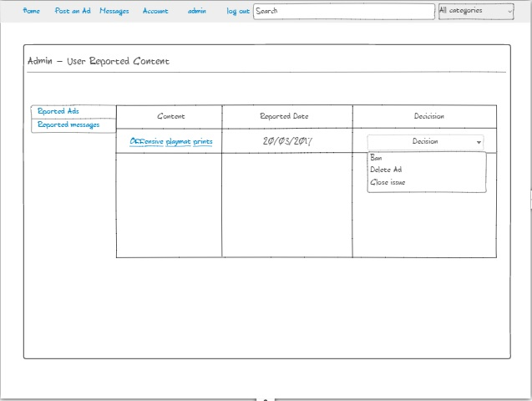  
Figure 16 – Reported content page**

This is the reported content page. Here the admin can see all content flagged by users that they viewed was offensive or inappropriate. In the left column there is a link to the content in question, in the middle is the date the content was reported, and on the right is a drop down menu containing the option to un-flag the content, ban the user who was reported, or close the report with no issue. The admin can select if the wish to view ads or messages in the menu to the left of the table.

**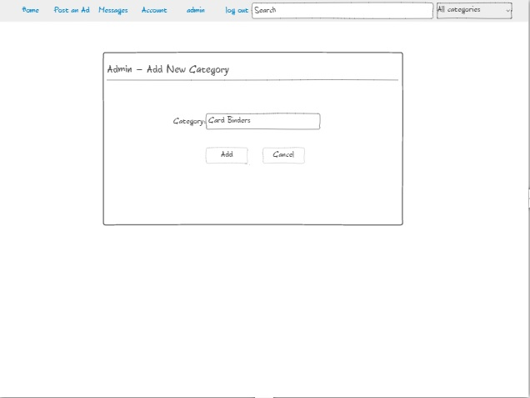  
Figure 17 – Add new category**

When the admin clicks on the add new category button they are brought here. Here the admin can type in a category and add it to the database for later use in ad posting.

**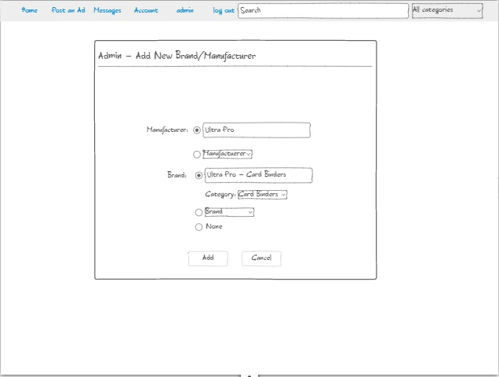  
Figure 18 – Add new manufacturer/brand**

When the admin clicks the add new manufacturer/brand they are redirected to this page. Here they can select either to add new manufacturer or use an already entered manufacturer. Type in a new brand and select the corresponding category, select an already existing brand, or no brand just a manufacturer.

**Database diagram:**

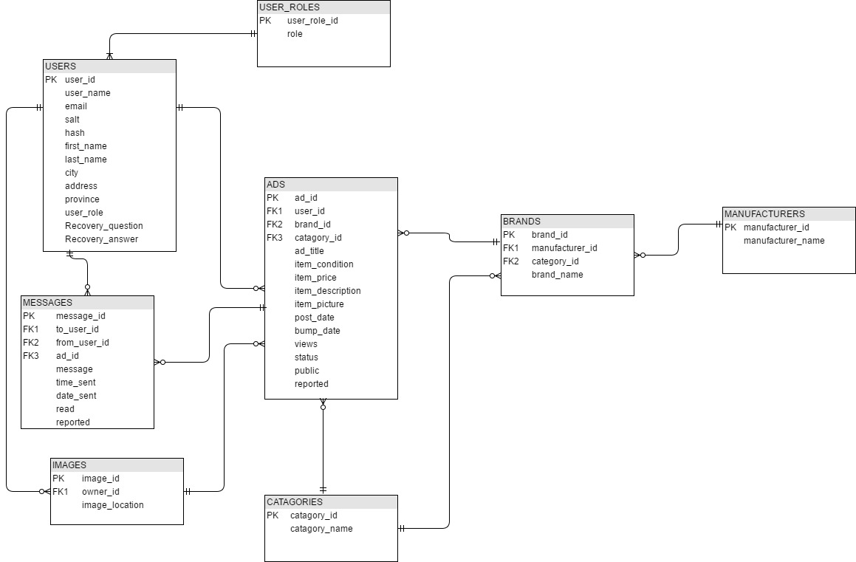

**Test plan:**

I intend to do my testing with an automated tool called Selenium, my test plan is as follows.

Test to pass

1. Search for an ad using the search bar when not logged in.
2. Create a new user account
3. As an user search for an ad again
4. Message an user about their ad
5. Create a new ad with valid information
6. Edit the new ad
7. Delete the ad
8. Create the ad again
9. Log out and create another user account
10. Search for the created ad and send a message to the user using the contact button
11. Report the ad
12. Log out and log back in with the other user account
13. Check messages for the message
14. Report message
15. Reply to the message
16. Log back into the other user to see if the reply was received
17. Report reply
18. Log out
19. Log into an admin account
20. Check reported content
21. Check for reported ad
22. Delete the ad
23. Check reported messages
24. Close report without issue
25. Ban user
26. Go back to admin panel and select add new category
27. Enter a new category and press submit
28. Go to the admin control panel and select add new manufacturer/brand
29. Enter a new manufacturer and brand
30. Check the search for new manufacturer, brand and category.

Test to Fail

1. Attempt to access restricted pages without permissions
2. Attempt to log in with invalid credentials
3. Attempt to sign up with invalid data to all fields
4. Attempt SQL injection in all available fields
5. Attempt to create new ad with no information in any of the fields

**Development plan**

|  |  |
| --- | --- |
| Week 1  Sept 5th – 8th | Set up tools, CodeIgniter, and database |
| Week 2  Sept 11th – 15th | Create the index page, search page, create user page, and admin pages |
| Week 3  Sept 18th – 22rd | Test the search page, create user page, and admin page. |
| Week 4  Sept 24th – 30th | Add Navigation, and admin add abilities |
| Week 5  Oct 2st – 6th | Test the adding new categories, brands and manufacturers |
| Week 6  Oct 9th – 13th | Add form validation to all required fields |
| Week 7  Oct 16th – 20th | Test form validation |
| Reading Week  Oct 23nd – 27th | Create user messages page and reporting functionality |
| Week 8  Oct 30th – Nov 3th | Test user messages and reporting |
| Week 9  Nov 6th – 10th | Add password recovery, make sure the security question is used |
| Week 10  Nov 13th – 17th | Test every field for SQL injection |
| Week 11  Nov 20th – 24th | Add any extra features and test them for errors |
| Week 12  Nov 27th – Dec 1st | Fully test and look over project for any errors a final time |
| Week 13  Dec 4th – 8th | Present project |